Retail investors have a surprising new favourite:

Treasury bills 散户投资者有了一个令人惊讶的新宠：国库券。

Banks face a fresh form of competition

Oct 12th 2023

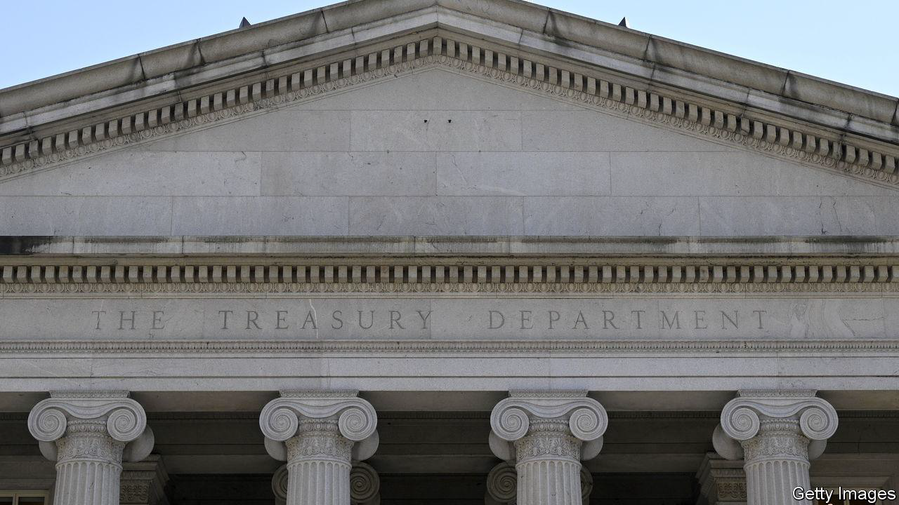

WHEN TREASURY bonds (or T-bills) last yielded as much as they do today—5.5%—punters were relieved that the world had not been destroyed by the millennium bug, Destiny’s Child were atop the charts and the dotcom bubble was going strong. The recent surge in yields has been remarkable (see chart).

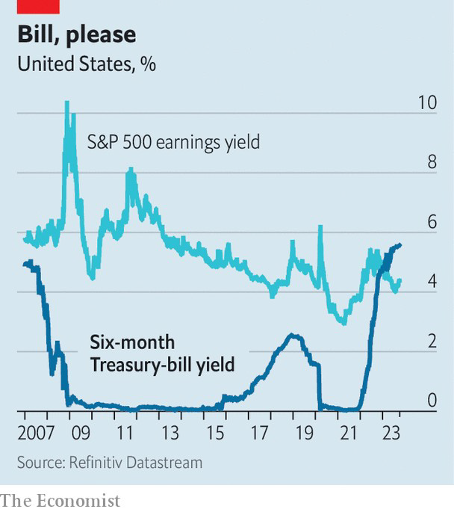

当美国国债（或国库券）的收益率与今天的收益水平不相上下时（5.5%），投资者们松了口气，因为世界没有被千年虫摧毁，命运之子(Destiny’s Child)在排行榜上名列前茅，互联网泡沫正在强劲发展。最近收益率的飙升非常引人注目（见图）

Yet bank depositors are seeing just a fraction of these increases. The average American savings account yields just 0.45%. Investors, too, are missing out. For the first time in over two decades, at the end of last year the return offered by six-month Treasuries overtook the earnings yield of S&P 500 companies.

然而银行储户看到的只是这些增长的一小部分。美国储户的平均收益率仅为0.45%。投资者也是如此。去年年底，

六个月期国债国债回报率首次超过了标准普尔500指数公司的盈利收益率，这是二十年来的首次。

So retail investors are looking elsewhere. Trading platforms have made short-term Treasury products a big part of their offering. Advertisements for Public, one such platform, ask podcast listeners if they are aware of the meagre savings rate on their deposit accounts. Despite only having been available on the platform since March, Treasuries are now its most purchased asset. One in ten new users buy them as their first trade.

因此散户投资者正在寻找其他的投资地方。交易平台已将短期国债产品作为其产品的重要组成部分。一个该类型的平台，公众广告平台，通过广告询问播客听众是否意识到自己的存款账户储蓄率微薄。尽管国债3月份开始才在该平台提供，但目前国债已成为其购买量最大的资产。十分之一的新用户将其作为第一笔交易购买。

Demand for Treasuries reflects a broader move towards safe, high-yielding options. Money-market funds invest in low-risk, short-duration instruments, including Treasuries. More than $880bn has been added to such funds this year, bringing their total value to an all-time high of $5.7trn. As with retail short-dated Treasury accounts, money-market funds are attractive to savers because they are highly liquid, meaning that cash can be withdrawn quickly if required.

对国债的需求反应出人们转向投资安全、高收益的选择。货币市场基金投资低风险、短期的工具，包括国债。今年此类基金的增资额已超过 8800 亿美元，使其总价值达到 5.7 万亿美元的历史新高。与零售短期国债账户一样，货币市场基金对储户很有吸引力，因为它们具有高流动性，这意味着如果需要，可以快速提取现金

The growing popularity of such alternatives is upsetting the logic of retail banking. Banks get away with providing interest rates well below the interest they receive from short-term government debt because—as Public’s advertisements identify—many depositors pay little attention. By sucking deposits from the banking system, money-market funds are thought to have contributed to financial instability in the spring.

这种类型的投资的日益增长使得零售银行的业务逻辑被扰乱。银行提供的利率远远低于短期政府债务的利息，因为正如公众广告平台所表明的那样，许多储户很少关注。通过吸收银行系统的存款，货币市场基金被认为是导致春季金融不稳定的原因之一

Retail-trading platforms’ expansion has made it easier than ever for depositors to transfer funds into short-dated government debt. That may further erode the discount on savings rates that depositors will accept from banks, and make Treasuries a bigger feature in retail-investment portfolios.Savers will, then, be singing along to one of Destiny’s Child’s better tunes: “Bills, Bills, Bills”.■

零售交易平台的扩张使储户比以往任何时候都更容易将资金转入短期政府债务。这可能会进一步削弱储户从银行接受的储蓄利率折扣，并使国债成为零售投资组合中的一个更大的特征。储蓄者将会跟随Destiny's Child一同歌唱一首更好的歌曲《账单，账单，账单》。”